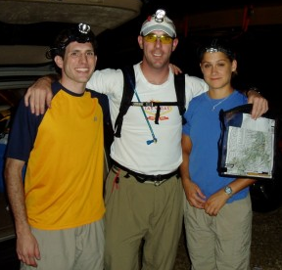
The Driftless Zone

The Driftless Zone was a 20hr race in southwestern Wisconsin in the “driftless area”, an area the glaciers missed during the ice age 10,000 years ago. The race began and finished at the Rockton Bar and traveled through both the Wildcat Mountain State Park and the Kickapoo Valley Reserve. Sean and I (Jill) raced as a 2 person team, team Aggressive Behavior, and Matt was our crew person.
Matt Sean Jill

The Beginning:
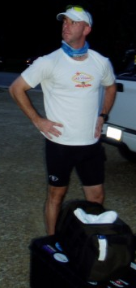
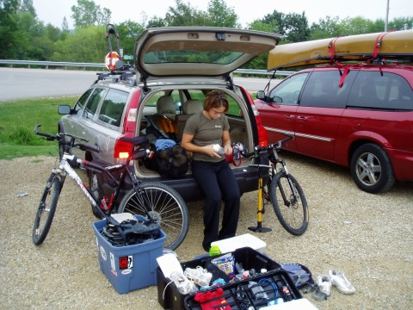
After a pre-race meal at the Rockton Bar, we had a few hours to get our gear and ourselves ready for the race, which pretty much meant we goofed around and talked to other teams. The 9:00 pm pre-race meeting was short and sweet and we were told that the first part of the race was treking. At 10:00 we were to congregate at a fence which separated us and our support crew. Matt was given an envelope containing 2 blindfolds. Sean and I had to put these on and then get 1 map and 2 sets of instructions. We decided to link arms and walk straight towards the map holder in front of us, split up, and follow the grass line to get the other race instructions. We got the map immediately, then we split up. I was in the dark, blindfolded and running into racer after racer listening to all the other support crews scream at their teams. Matt could only direct one of us, which of course was Sean, so I was on my own. Eventually we got the race instructions, ripped off our blindfolds, and headed to a picnic table to plot the UTM coordinates. This happened fairly quickly and we were off.
The
International Look

The Trek:
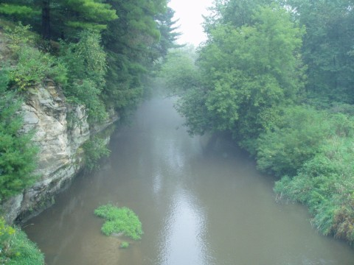
As we ran towards the first check point, Sean gave me a map to hold. I didn’t think this was such a good idea, but he let me hold it the entire section of the race. Most of our ‘map’ conversations went like this: “Where are we Sean?”; “We’re right there (pointing to my map).”; “Oh, okay then we need to go this way”. Before the first checkpoint Sean explained to me that we needed to find #1 right away to boost his confidence since he hadn’t picked up his compass in a long, long time. And that’s exactly what we did. We then proceeded out to a trail and onto checkpoint #2. We were trying to find a way into the woods from the road but kept coming upon these huge rock faces that did not look climbable. Finally, another team plowed ahead and we followed them up through a break in the rock face. According to the map the checkpoint looked as if it was on the top of a hill. Once we got to the top, we couldn’t find it. Wedali passed us, backtracking, and looking for the point. Us and Team Jen’s Men were scouring the top of the hill, the sides, backtracking, retracking, and still couldn’t find it. In the mean time about 5 other teams had come to the top of the hill searching for the elusive check point. After about 50 minutes of searching (and getting crabby), Sean and I decided to head to the next hill over. It was then that we realized this was probably the right hill, but we still couldn’t find that dumb orange and white flag. Finally I walked out into an open field and Sean followed. At this point we had been looking for #2 for about 1.5hrs. We were trying to decide if we should just bag it or continue looking. I saw a different hill and said “how about we look up there?” Sean looked and said “@#^&%$, its right there”. The flag was about 10ft to my left, right on the edge of the open field. On our way to checkpoint #3 Sean said that his spirits were much higher after finding #2. I wholeheartedly agreed. We headed to the road, and ran into some teams we were on the top of that hill with. We showed them where #2 actually was, the hopped on a trail, and crossed the river to find #3. We found it much, much quicker than #2. After leaving #3, we needed to head straight west to hit a trail. The problem, however, was that straight west, was straight into a patch of stinging nettles. We stopped, considering our options. Actually it was mostly Sean doing the considering since I was on the brink of losing my mind. We decided to plow forward and get out of the nettles then figure out where we were. We went about 20ft and by divine intervention we came upon the trail we were looking for. The next two checkpoints were on trails and found easily. It was on these trails that we realized why the off road bike section was cut from the race. The trail we were on dipped down and I walked right into about a 6 inches of mud. My feet were stuck and to maintain my balance I started windmilling my arms. Luckily at the last minute Sean stuck out his arm, I grabbed it, and thankfully didn’t face plant into the mud. He then said he was glad I was the one in front. Our next point was across an open field. We came to a T in the road, shot a bearing, and headed across the field. We plunged into the woods and spent about 45 minutes scouting up and down this rock formation, then further down to the river shore. After a while, I said to Sean “I think we’re over thinking this one”. All the other checkpoints (except for the first one) were on trails or edges of fields. So we decided to go back out to the field and start over and what before our wandering eyes should appear right on the edge of the tree line? Checkpoint #6. For the next 15 minutes we hated ourselves for being so stupid. Next, we popped out onto a road and decided to climb up the back of Mount Pisgah (the top was #7) rather than skirt around to the trail. On our way up we ran into another team with the same idea. Up and up we went until we came to a steep rock face. The other team found a break in the rocks, and scrambled through to the top. While waiting for them to get through, Sean says “why don’t we take that staircase in the rock right there”. So we climbed up that way and met the other team at the top. At this point I was out of food and getting low on water. I ransacked Sean’s pack and unexcitedly found a goo for each of us (those things make me gag). We followed the trail to the checkpoint then followed it on down the mountain. About halfway down I twisted my ankle and ran out of water, but we made friends with the other team (the Iowa Boys, Gary and Jed) who turned out to have raced with someone we had raced with before. We finally came to an opening near a parking lot with a water fountain. The water was fantastic and Sean and I headed off…in the wrong direction. The Iowa Boys went the right way and we didn’t catch up to them until the next checkpoint in the woods. We all went on to checkpoint #8 which was at the top of a bend in the Kickapoo river. We came to a bend in the road and shot into the woods to find the river. This was harder than we thought because we were about 50ft up on sheer rock faces. We were troubled by the fact that we couldn’t hear the river either. Finally we found a way down and a way into more stinging nettles. I finally heard the river and we saw the bend. We crossed to the right side, only to spend another 45 minutes looking for this point. Jen’s Men caught up to us and they had the brightest head lamps I had ever seen. Sean called them car headlights. Those headlamps made it real difficult to secretively pee in the woods. There were at least 3 or 4 teams also looking for this check point. After pursuing a couple of ideas we all decided to fan out and look deeper into the woods than we had before. I said to Sean, “Oh I think I see it on top of that hill”. So I walked closer and couldn’t see it anymore and said “or maybe I’m delirious”. So Sean climbed to the top of the hill and found the checkpoint. We called to all the other teams that were looking with us, got out of the woods, and on to the last checkpoint before transition. The sun was starting to come up and in spite of not having eaten anything for the last 3hrs I wasn’t feeling too bad. Us and the Iowa Boys got the last checkpoint and headed on in to transition. We found out from the race director that we were the first teams to come in that had all the checkpoints. I headed straight to my chicken sandwich. A McGrilled Chicken Sandwich never tasted so good. Sean and I took a little long in this transition to refuel and recoup.

The Paddle:
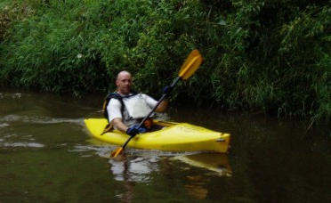
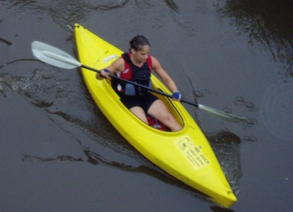
We changed out our canoe for kayaks and got on the river. What a beautiful paddle! The Kickapoo river had lots turns with amazing rock faces along the river’s edge. The river was fast and there were a few mini-rapids which were fun. We even saw a beaver swimming nearby. We paddled 16 miles in about 5 hours from bridge 1 to bridge 14. We pulled our kayaks out just past bridge 14 and got new race instructions at this point. The next section was a bike section and we were given a new map and new UTM coordinates. I placed the map on the hood of the car and started plotting points while Sean changed his shorts. He came over and said “Do you know what you’re doing?” I said, “Kinda. I saw you do it last night. Here check the first one.” I actually plotted it right! So he let me do the others while he routed our course. We hopped on our bikes and were off.
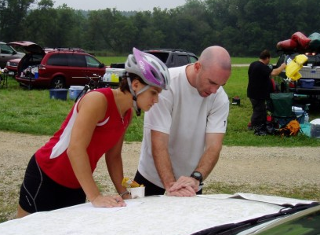
The Bike:
I was so happy to not be paddling any more that I took off. We got to the first bike check point and I was exhausted. I said to Sean that we needed to slow down. He agreed after he pointed out that I was the one who set the pace. Our next point was far and we spent a lot of time biking on Hwy P. This was not my favorite road; however, the very last bit of it was a fast descent onto a nice, flat, smooth road. We worked our way to the town of Hillsboro and found the next checkpoint at a trail head, thanks to a team dressed in orange who pointed it out. On our way to the ropes section of the race we ran into the orange team again on a two track. They said the two track dead ended and were going back. Sean looked at the map and said that we needed to cross a creek first. So we continue on and come to the creek edge. I only had one pair of dry socks and they were on my feet. So I took off my socks and shoes and put them in my pack. I slid down the edge of the muddy bank and stepped into the river. It was up to my waist at the shore. Sean handed me my bike and holding it above my head, I started to cross the river. It got deeper and deeper, til eventually it was at my chin. So much for saving my dry socks. I remember thinking that at least my helmet floats. Tip toeing while listening to Sean dying laughing I finally made it to the other side without drowning. He followed and we biked on into the transition. We checked in, donned our climbing gear and headed over to the ropes section.

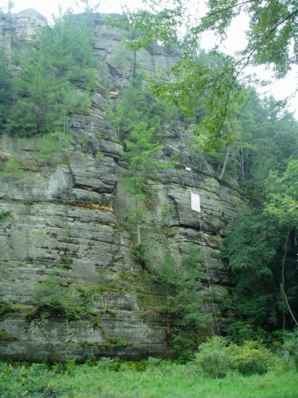
The Ropes:
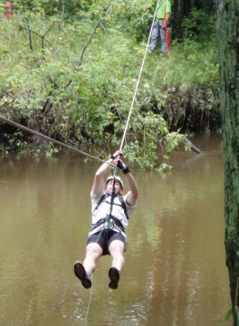
The ropes section began with a traverse across a river where you had to lock into the pulley yourself. Sean helped me get in and I went across the river. I had to get off by myself so I hooked one leg over the rope and pulled myself up with my left arm. The stupid lock on the carabineer wouldn’t twist down far enough and after some struggle I finally got off the rope. Sean came across and I pulled down on the rope to help him off. Next we had to find our way up to the top of a cliff. We could see the ropes and the people at the top but didn’t know how to get up there. We skirted around the base of the hill and found a place to ascend near the back. At the top the ropes guys helped me get on the rope and set up a self belay system. As I was leaning over the edge of this 180ft cliff, I got a little nervous that this late in the race my arms would fail me. They didn’t and the repel was the most awesome one I’ve ever done. At the bottom we then had to traverse back across the river. Back in transition we were given more race instructions and the final check points to plot. It was essentially a return bike with one checkpoint on the way to the finish.

The Finish:
We left the ropes section and biked back along the route we came on. I was not looking forward to Hwy P, but when we got onto that road I realized why I hated it so much. It was mostly a gradual uphill the whole way out. We snagged the last checkpoint and biked on into the finish around 4:30, 18.5 hrs after we started. We had come in 3rd place overall, and 1st place in our 2 person coed division. After about 5 minutes of standing around the finish, I got my complimentary plate of BBQ chicken and sat down to eat. I don’t think BBQ chicken ever tasted so good. Later we found out that the 2 teams that came in before us did not have all the checkpoints. Joe, the RD, later informed me by email that we had won the entire race, being the first team to cross the finish line with all the checkpoints.

